Screenshots or program listings must be copied into appropriate cells in the following table.
Save this evidence document as evidence_ followed by your centre number_ candidate number, for example, evidence_ zz999_9999 and insert your name, centre number and candidate number into the header above.
Examiners must be able to read the contents including any screenshots without the use of a magnifying glass.
Answers that are not readable or are missing will not be awarded any marks.
Email this file to: “Exam.aqibkhan@gmail.com”
Save this evidence document at regular intervals, for example every 10 minutes.
Question 1
Part a – 4 marks
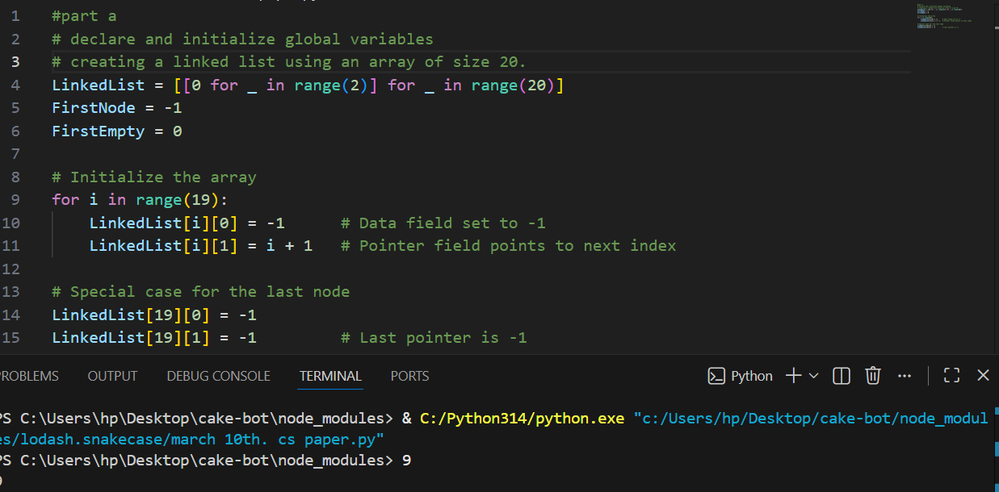

Part b – 6 marks
{Copy and paste program code listing for 1(b) here}
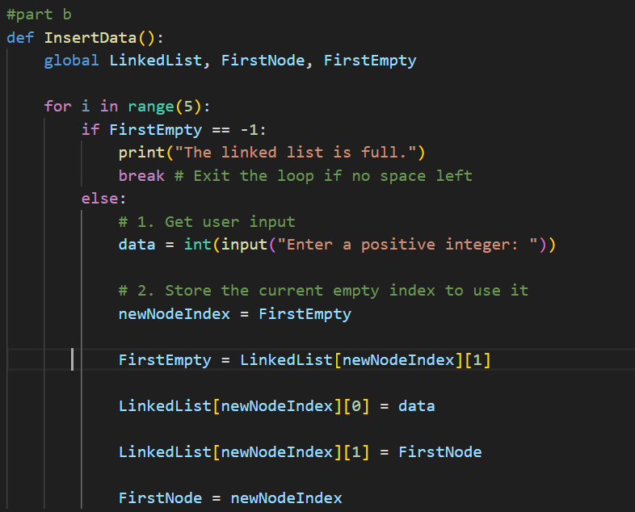

Part 1 c (i)- 4 marks
{Copy and paste program code listing for Question 1(C)(i) here}
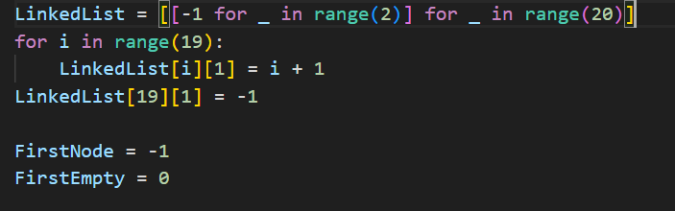

Part 1 c (ii)- 4 marks
{Copy and paste program code listing for Question 1(C)(i i) here}
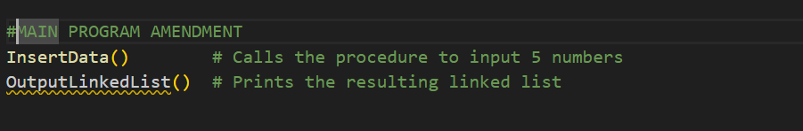

Part 1 c (iii)- 2 marks
{Copy and paste screenshot for Question 1(C)(iii) here}

